# Developing stage-discharge rating curves for two sites at Papa Stream, Nu’uuli Village, American Samoa

### Authors:

Messina, A.M.a

a San Diego State University, Department of Geography, San Diego, CA 92182, amessina@rohan.sdsu.edu, +1-619-594-5437

# Introduction

Coral reefs around the world are threatened by increased sediment stress caused by human disturbance on the landscape and increased erosion. Suspended sediment attenuates light for photosynthesis, accumulates on corals, and blocks sights for larval recruitment. Successful management and sediment load reduction requires identifying key sediment sources and quantifying their contributions to the total loading from the watershed. Field-based approaches have focused on measuring the suspended sediment load discharged by the watershed (or subwatersheds), using stream gaging techniques. Suspended sediment yield is calculated directly from measurements of water discharge and sediment concentration, so the measurement of stream discharge is critical for the analysis of sediment loads. The most common field technique for monitoring continuous water discharge in a natural stream is to develop a stage-discharge rating curve from field measurements of water discharge. The rating curve is then used to convert continuous stream stage measurements to continuous discharge.

In the study watershed, two sites were selected to monitor sediment yield from the upper, undisturbed subwatershed (UPPER) and the lower, human-disturbed watershed (LOWER) drained by Papa Stream in Nu’uuli Village, American Samoa. In future work, sediment load will be calculated at these points to determine sediment contributions from each subwatershed to the total sediment load from the watershed. This paper presents the development of stage-discharge rating curves at two sites on Papa Stream which will be used to calculate sediment load.

## Study Area

The study watershed (Nu’uuli) is a subwatershed of Nu’uuli Village, located on Tutuila (14S, 170W), the largest island in the Territory of American Samoa (140 km²)(Figure 1). Nu’uuli watershed (2.1km2) is drained by Papa Stream, which runs the length of the watershed (~3km), and several small tributaries. Like many volcanic islands in the Pacific, Tutuila is composed of steep, heavily forested mountains with villages and roads mostly confined to the flat areas near the coast. The study watershed includes Matafao Mountain, the highest point on Tutuila (653 m), and the stream discharges into the Pacific Ocean. The mean slope of the watershed is 0.53 m/m and total relief is 653 m.

Precipitation on Tutuila is caused by several mechanisms including cyclones and tropical depressions, isolated thunderstorms, and orographic uplifting of trade-wind squalls over the high (300-600 m), mountainous ridge that runs the length of the island. Unlike many other Pacific Islands, the ridge runs parallel to the predominant wind direction, and does not cause a significant windward/leeward rainfall gradient. From 1903 to 1973, average annual precipitation over the island was 3,800 mm/yr (Eyre, 1989; Izuka et al., 2005). Precipitation increases with elevation, from an average 2,380 mm/yr at the shoreline to 6,350 mm/yr at the highest elevation on the island. There are two subtle rainfall seasons: a drier winter season, from June through September and a wetter summer season, from October through May (Izuka et al., 2005). During the drier winter season, the island is influenced by relatively stronger, predominantly east to southeast tradewinds, lower temperatures, lower humidity and lower total rainfall. During the wetter summer season the Inter-Tropical Convergence Zone (ITCZ) moves over the region, causing light to moderate Northerly winds, higher temperatures, higher humidity, and higher total rainfall. While total rainfall is lower in the drier tradewind season, large storm events are still observed.

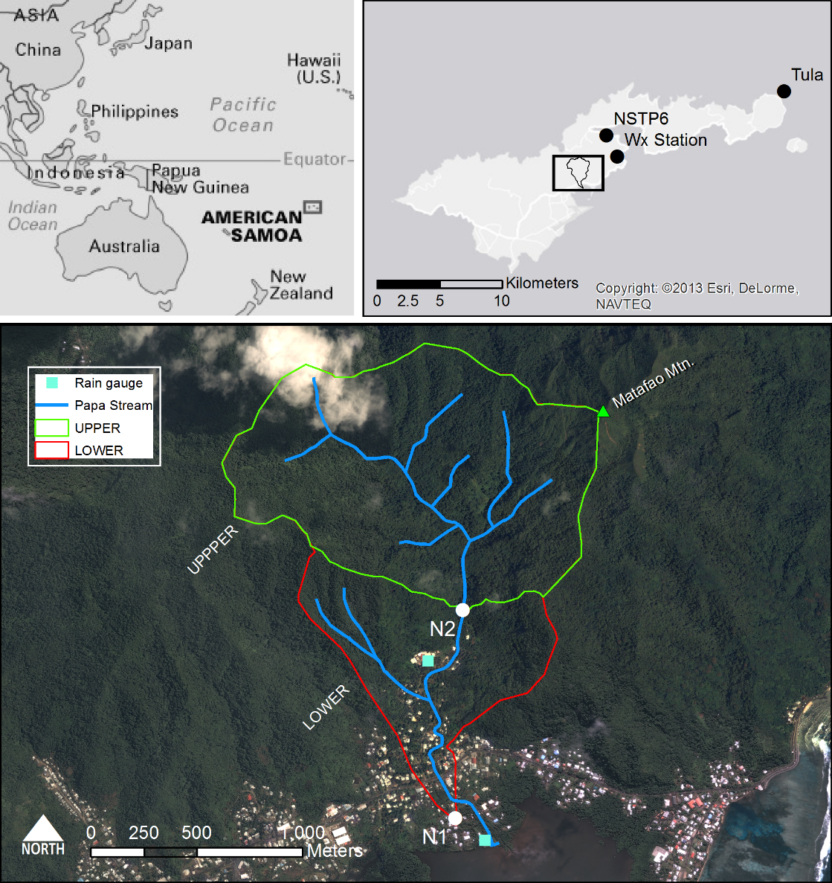

Figure . Nu’uuli watershed showing the UPPER (undisturbed) and LOWER (human-disturbed) subwatersheds. The LOWER subwatershed drains areas between N2 and N1. Barometer locations at NSTP6 and TULA shown in top-right.

The predominant land cover in Nu’uuli watershed is undisturbed vegetation (98%), including forest (94%) and scrub/shrub (4.3%) on the steep hillsides (Table 1), based on a land cover map from NOAA’s Ocean Service and Coastal Services Center (2010). The upper watershed (UPPER) is dominated by undisturbed rainforest on steep hillslopes. The lower subwatershed (LOWER) has steep vegetated hillslopes and a relatively small flat area in the valley bottom that is urbanized. This settlement pattern is typical in the South Pacific and other volcanic islands, where their small size and steep topography constrain development to valley bottoms near the coast (Bégin et al., 2014).

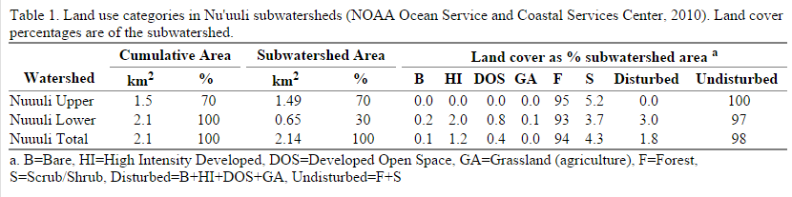

# Methods

The most common method for measuring discharge is the area-velocity method using a flowmeter (Turnipseed and Sauer, 2010). A Marsh-McBirney flow meter was used to measure flow speed at 0.5 foot intervals across the stream, and discharge was calculated as the sum of flow speed over each interval and the cross-sectional area of that interval. Discharge measurements were taken over a range of flow conditions, and related to stream stage using a log-linear fitting method (power law).

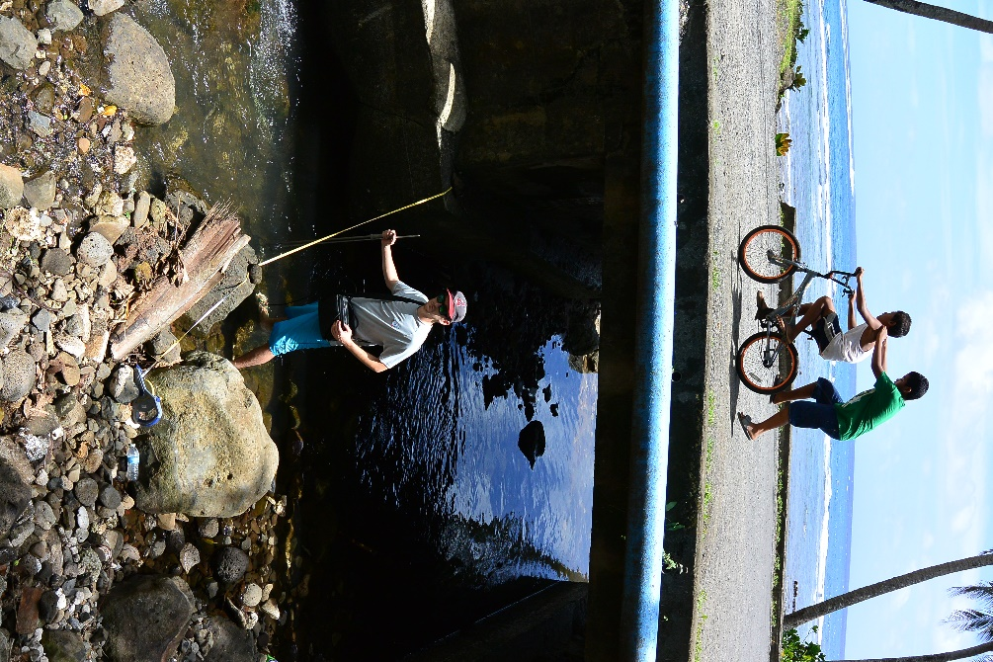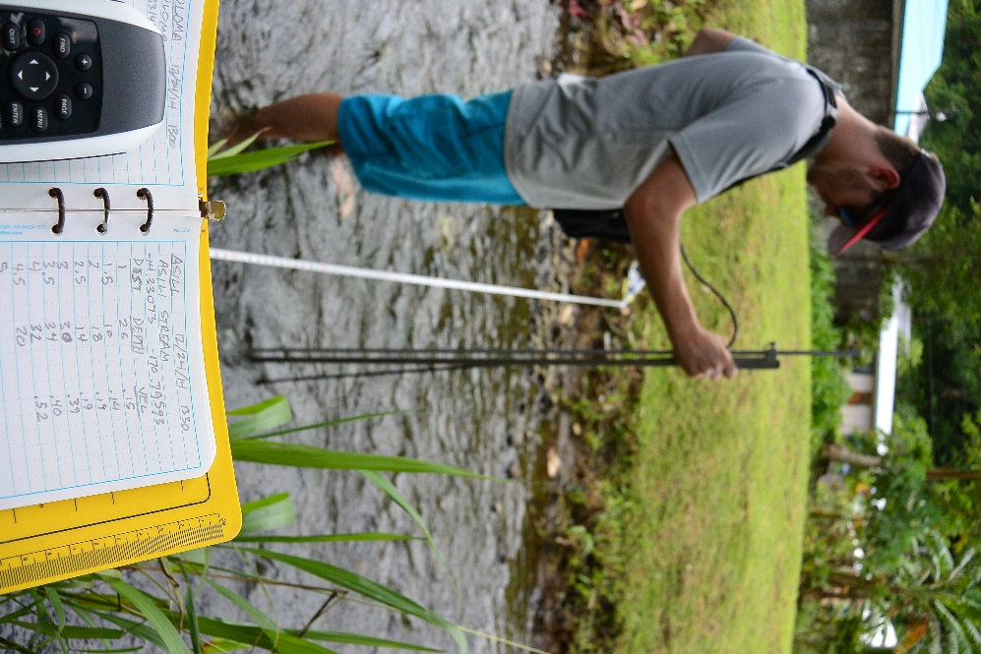

Figure . Field assistant Greg McCormick measuring discharge using a Marsh-McBirney flow meter and the area-velocity method. Photos: Messina.

Discharge was also calculated from Manning’s equation for flow in open channels and the cross-sectional area of the channel (eq. 2), which was measured in two ways, 1) A cross-section was surveyed using an Auto-Level and Survey rod and 2) cross-section measured with the top-setting wading rod during the area-velocity discharge measurement. Discharge calculated with Manning’s equation is sensitive to the choice of the n parameter, which can vary with changing vegetation growth and sediment deposition in the channel. Discharge is calculated from Manning’s equation:

|  |  |  |
| --- | --- | --- |
|  | $Q= \frac{k}{n} {R_{h }}^{\frac{2}{3 }}* S^{\frac{1}{2}}*A$ | 1 |
| where *Q* is discharge (L1 T-1), *k* is a conversion factor (1.436), *n* is Manning’s n value, *R* is hydraulic radius (m), *S* is slope (m/m), and *A* is cross-sectional area. | | |

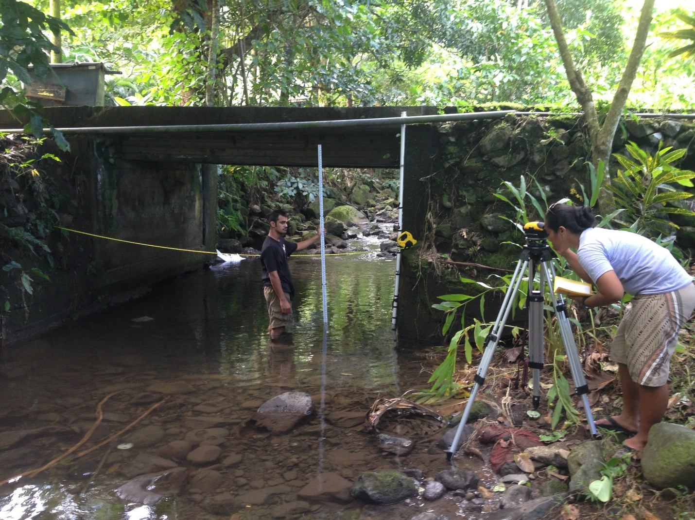

Figure . Field assistants Rocco Tinitali and Valentine Vaeoso surveying the stream cross-section at site N2, under baseflow conditions. Photo: Messina.

Stream stage was recorded at 15 minute intervals at both sites using a data-logging pressure transducer (PT) installed in a PVC pipe stilling well. PT’s record the total hydrostatic pressure and must be corrected for atmospheric pressure. PT pressure data is converted to stage height by subtracting simultaneously recorded barometric pressure from the PT pressure data (Equation 1).

|  |  |  |
| --- | --- | --- |
|  | $$Stage = \frac{PT-Baro}{g* ρ*100}$$ | 2 |
| where Stage is stage height (cm), PT is recorded pressure from the PT (hPa ), Baro is barometric pressure (hPa), g is gravity (9.81m1s-2), ρ is density of water (1kg1 L-1), and 100 (cm1 m-1). | | |

Barometric pressure from three stations was used: a Davis weather station, a NOAA tide station, and a NOAA Climate Observatory (Figure 1, top right). A Davis Vantage Pro 2 weather station (Wx) was installed in nearby Faga’alu watershed, near the stream mouth. Where barometric data from Wx was not available, data from a NOAA National Data Buoy Center tidal station (NSTP6) in Pago Pago Harbor (4 km away), or from a NOAA Climate Observatory at Tula (17.5 km away).

# Results

## Stage Data

Stream stage was calculated from PT data at N1 and N2 and barometric pressure recorded at the weather stations (). The PT at N1 was vandalized and destroyed in July 2013 so no data was available until it was reinstalled in March 2014. Data for N2 was not recorded from May-October 2014 because its memory was filled, and could not record any more data.

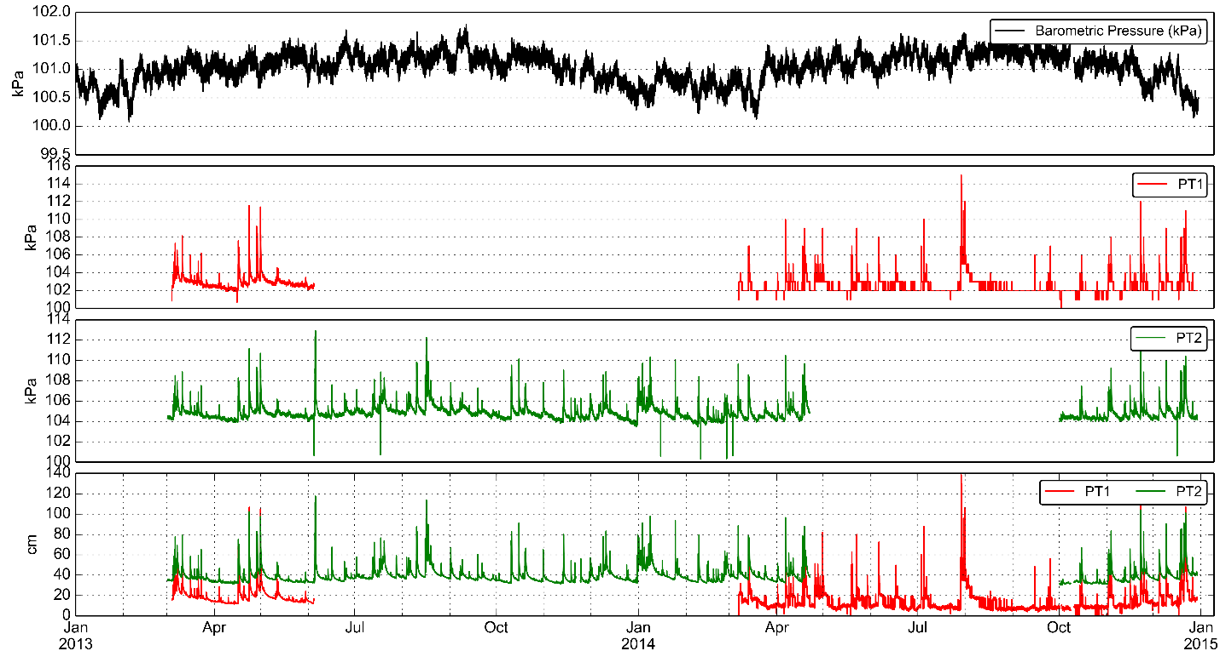

d)

c)

b)

a)

Figure 4. (a) Barometric pressure, (b-c) PT pressure at N1 and N2, and (d) stream stage at N1 and N2 during the study period.

## Site N1

Site N1 is located at a bridge on Highway 001, the island’s most heavily trafficked road (). Due to the complex shape of the bridge culvert, and significant sediment deposits, the PT was located immediately downstream of the bridge where the banks are stabilized by concreted rip-rap, and the stream bed is a concrete footing. No sediment build up was observed during the monitoring period and no erosion of the concrete footing is possible.

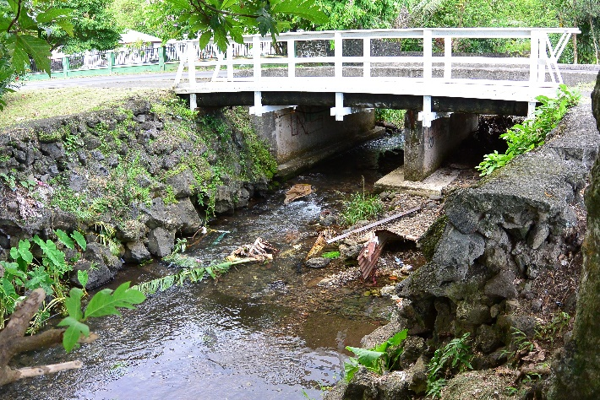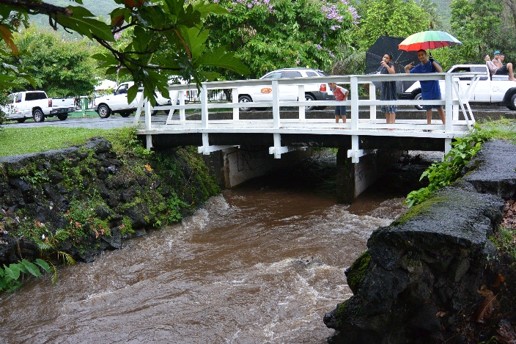

PT location

**b)**

**a)**

Figure . Site N1 under (a) baseflow and (b) stormflow conditions. Surveyed cross-section location illustrated in (a); PT location illustrated in (b). Photos: Messina.

The stream cross section at Site N1 was approximately trapezoidal (Figure 5), with some large rip rap boulders at the toe of the stream bank slope, and along the stream banks. The slope profile is fairly gentle (0.013 m/m), which reflects its location down on the flat part of the valley bottom, near the outlet to the ocean.

Figure 6. Surveyed cross section and longitudinal profile at Site N1 (downstream) outlet of the LOWER subwatershed, and TOTAL watershed. PT location is at 0 feet distance in the longitudinal profile.

Four discharge measurements were made at N1 (3/11/13 and 12/17/14) over stream stages ranging from 11-28 cm (Figure 7).

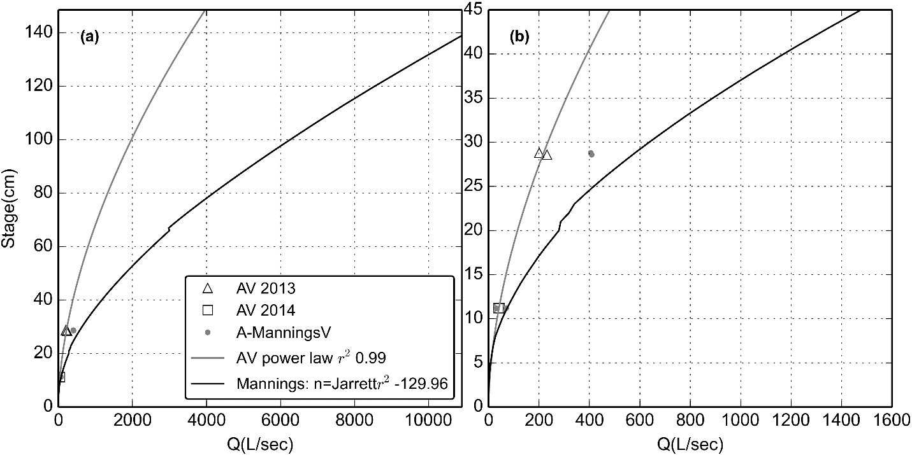

Figure 7. Stage-Discharge rating curves for Site N1.

## Site N2

Site N2 is located at a small bridge on a village road, near the furthest upstream houses. This site is not the outlet of the UPPER subwatershed but was chosen because it has stabilized banks, and is only about 100m downstream of the UPPER subwatershed. The water depth was relatively high at low flow, compared to Site N1, and the stream bed is composed of loose gravel and cobbles, unlike the cement bed at N1.

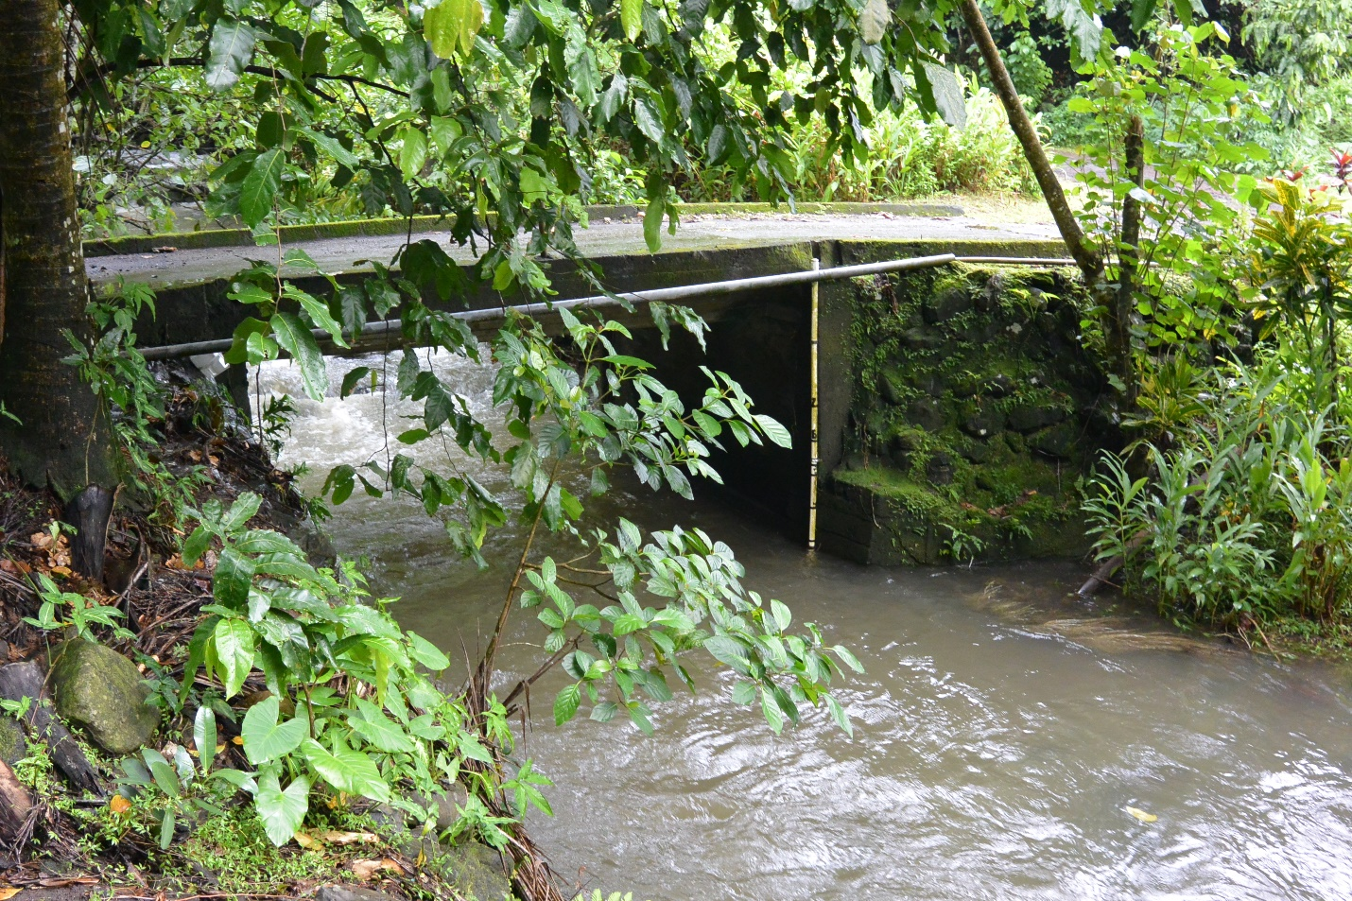

PT location

Figure 8. Site N2 under stormflow conditions. The PT is installed in the white, PVC tube attached to the downstream side of the bridge.

The stream cross section at site N2 is fairly flat with little variation in depth. The elevation profile showed the slope was slightly steeper than at N1, which is expected given its upstream location where the mountains steepen. The slope at N1 was 0.023 m/m.

Figure 9. Surveyed cross section and longitudinal profile at Site N2 (upstream) outlet of the UPPER subwatershed. PT location is at 0 feet distance in the longitudinal profile.

Due to the high depth at N2 under all flow conditions, it was difficult to measure discharge by wading, so only two discharge measurements were made over stream stage from 36-45 cm (Figure 10). Given the limited range of stream stages for these measurements, the rating curve cannot be constructed from measurements alone.

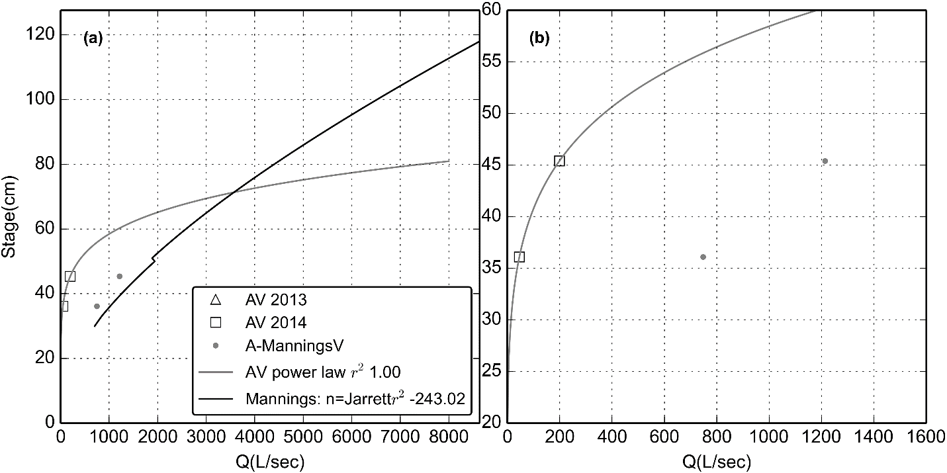

Figure 10. Stage-Discharge rating curves for Site N2.

# Discussion

The rating curves calculated from Manning’s equation did not work well for either site.

# Conclusion

# References

Bégin, C., Brooks, G., Larson, R. a., Dragićević, S., Ramos Scharrón, C.E., Coté, I.M., 2014. Increased sediment loads over coral reefs in Saint Lucia in relation to land use change in contributing watersheds. Ocean Coast. Manag. 95, 35–45. doi:10.1016/j.ocecoaman.2014.03.018

Eyre, P.R., 1989. Ground-water quality reconnaissance, Tutuila, American Samoa, U.S. Geological Survey Water Resources Investigations Report 94-4142. Honolulu, HI.

Izuka, S.K., Giambelluca, T.W., Nullet, M.A., 2005. Potential Evapotranspiration on Tutuila , American Samoa. U.S. Geological Survey Scientific Investigations Report 2005-5200.

NOAA’s Ocean Service, Coastal Services Center, 2010. 2010 C-CAP Land Cover, Territory of American Samoa, Tutuila.

Turnipseed, D.P., Sauer, V.B., 2010. Discharge Measurements at Gaging Stations, in: U.S. Geological Survey Techniques and Methods Book 3, Chap. A8. Reston, Va., p. 87.